Challenge 1 — Insert at the Front

Q: Insert a new node at the start of a linked list. What is the complexity?
Discuss: How is this easier compared to inserting at index 0 in an array?

ANSWER : The time complexity of this process is O(1). The reason why inserting at the first index using linked list is easier than array is because it doesn't require to shift any elements in the list just for the insert number to be in the first index, we just have to put the insert number in front of the first index.
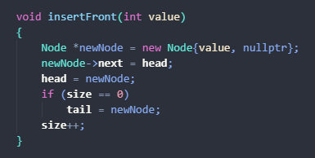

Challenge 2 — Insert at the End

Q: Append a new node to the end of a linked list. What is the complexity?
Discuss: Do we need to traverse the entire list? How does this differ from arrays?

ANSWER : The time complexity of this process is O(1) if we have a tail node to keep tracking the last node in the list. O(n) if we don't have a tail node because we have to loop through every node in the list to find the last node. The different form using an array is that we can access the last index in the array by index and we can’t easily access the last node in the list with index unless we have a tail node or loop through every node.
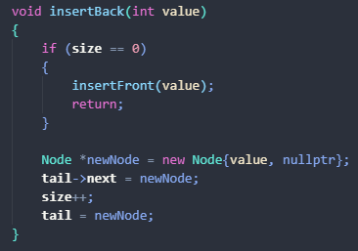

Challenge 3 — Insert in the Middle

Q: Insert a node between two existing nodes.
Discuss: Which two arrows (pointers) need to be changed? Compared to shifting in arrays.

ANSWER : The two pointers that need to be changed when inserted in the middle are the pointer that points from the first node to the second node and the pointer that points the insert node to the second node. From 1 -> 2 to 1 -> insert node -> 2. Compared to shifting half of the elements in the array this method of changing two arrow pointers takes pretty much the same time to execute. Let’s say if you have the size of both list and array, for list you have to traverse your current node to your prev middle node(side/2 -1) and insert it there and for the array you can just access the middle by size/2 and insert it there but you have to shift half of the array to the right. Both take n/2 times

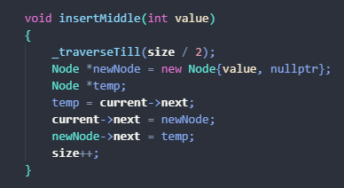

Challenge 4 — Delete from the Front

Q: Remove the first node.
Discuss: What happens to the head pointer? What about the deleted node’s memory?

ANSWER : When deleting the first node, the head pointer has to point to the node that comes after it and free the delete node to prevent memory leak. If we don't update the head pointer the list will crash. We don't know where the memory location of the first node if we dont update defore delete the program will crash

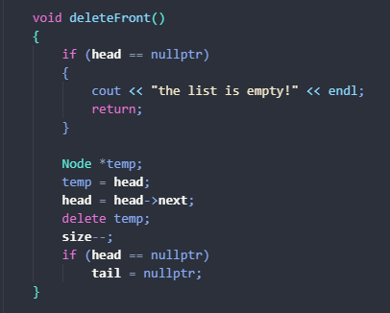

Challenge 5 — Delete from the End

Q: Remove the last node.
Discuss: How do we find the node before the last one?

ANSWER : to find the node before the last one requires traversal that loop through the whole list.
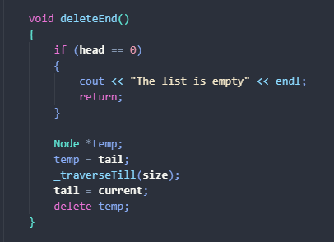

Challenge 6 — Delete from the Middle

Q: Remove a node between two others.
Discuss: Which arrow changes? What happens if we forget to free memory?

ANSWER : if we forget to free the delete memory it will cause a memory leak. The arrow that changes is the arrow of the previous node before the middle. We need to change it to point to the node that comes after the middle node.

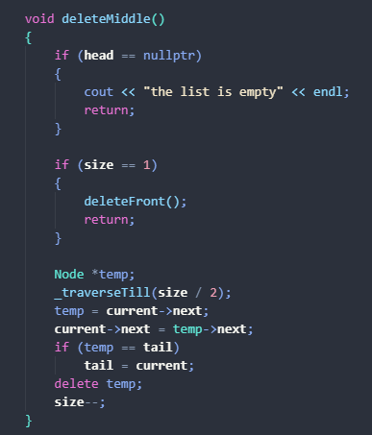

Challenge 7 — Traverse the List

Q: Print all elements in the linked list.
Discuss: How does traversal differ from direct arr[i] access?

Traversal take longer to do because we have to loop through the whole list to find what we are looking for, but in array we can just access it by index

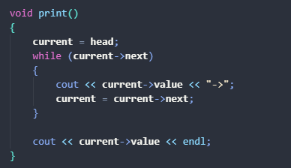

Challenge 8 — Swap Two Nodes

Q: Swap two nodes in the list (not just their values).
Discuss: Is it easier to swap values or swap links? Why?

Challenge 9 — Search in Linked List

Q: Search for a value in a linked list.
Discuss: How is this similar to linear search in arrays? Which one is faster for random access?

Searching in a linked list is similar to linear search in arrays — we go through each element one by one until we find a match.
However, unlike arrays, a linked list doesn’t support random access, so we can’t jump to an element directly by index. This makes searching slower in linked lists (O(n) time complexity).

Challenge 10 — Compare with Arrays
Q: For each operation (insert, delete, access), write the complexity for arrays vs. linked lists.
Discuss: In what situations is a linked list clearly better?

